Mapúa Univeristy

Intramuros, Manila

School of School of Electrical, Electronics and Computer Engineering

**Machine Problem: Address Book**

**User Manual**

Submitted by:

Jawod, Danielle Nicole O.

COE197P/E01

Submitted to:

Prof. Vincent Paolo Arellano

January 27, 2019

**Introduction** The machine problem is an address book program that can perform such functionalities like *Add Contact, Edit Contact, Delete Contact, View Contacts with sort and search functionality, Load Contacts via batch file,* and *Logs functionality*. Data of contacts from the address book are saved in a text file called “*addbook.txt*”. For every input of data, the program checks the validity of each and prompts the user with its corresponding output error/result. Such error and result prompts are recorded on a log text file called “*logs.txt*” which can also be accessed through the Logs Functionality of the program. When adding contacts into the address book, the “*First Name*”, “*Middle Name*”, and “*Last Name*” of the contact owner should be unique in order for the program to accept the provided contact, otherwise it will prompt the user that this particular person is already existing from the address book. The sorting algorithm used in this program to sort the data in ascending order is the *Selection Sort Algorithm*.

**Execution of the Machine Problem Address Book program**

The program can be executed by following the steps:

1. Open the terminal on the virtual machine and extract the JAWOD_MP.tar.gz on the home directory with the tar command.
2. Once extracted, change current directory to the extracted folder from the home directory named JAWOD_MP.
3. Change location of the PATH variable.
4. Apply executable permissions on each script files.
5. Run the mp.bash file to execute the program.

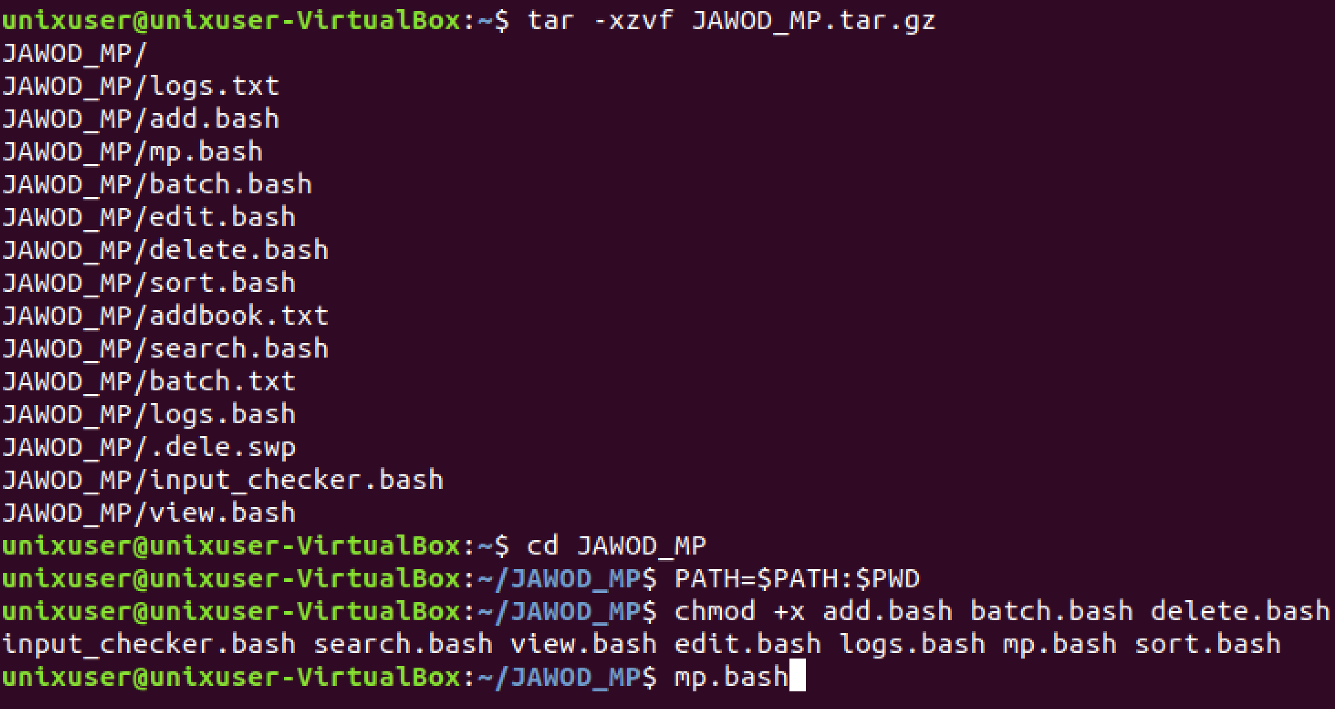

*Figure 1: Machine Problem Address Book execution*

**Machine Problem Address Book program**

Steps in using the Machine Problem Address Book program:

1. Once the program starts, it will prompt the user to choose an option specified with a corresponding option enclosed in [ ] for each functionality from the main menu displayed namely the Add Contact, Edit Contact, Delete Contact, View Contacts with sort and search functionality, Load Contacts via batch file, Logs functionality, and exit.

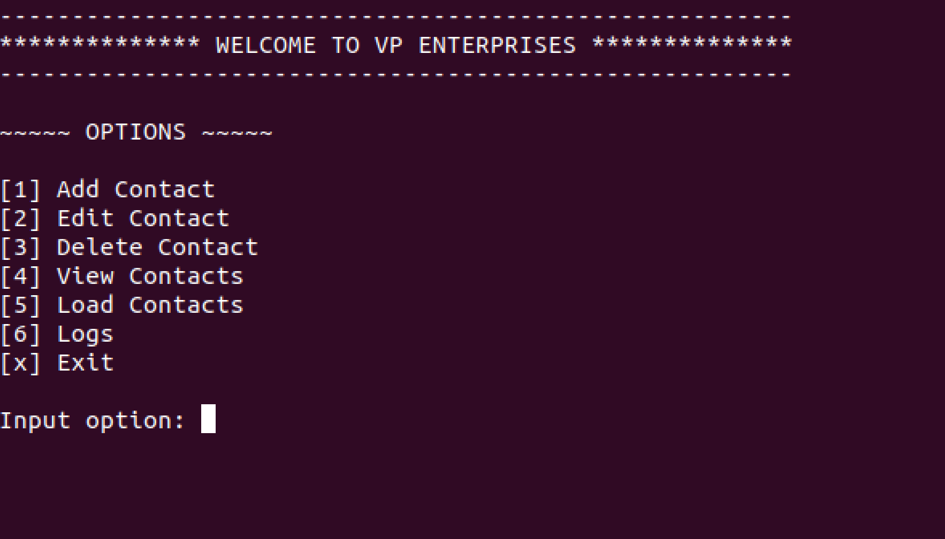

*Figure 2: Main menu page*

1. An invalid input will display an error prompt thus will ask the user to choose an option again. For a chosen option, the window display will be directed to the specified functionality page.

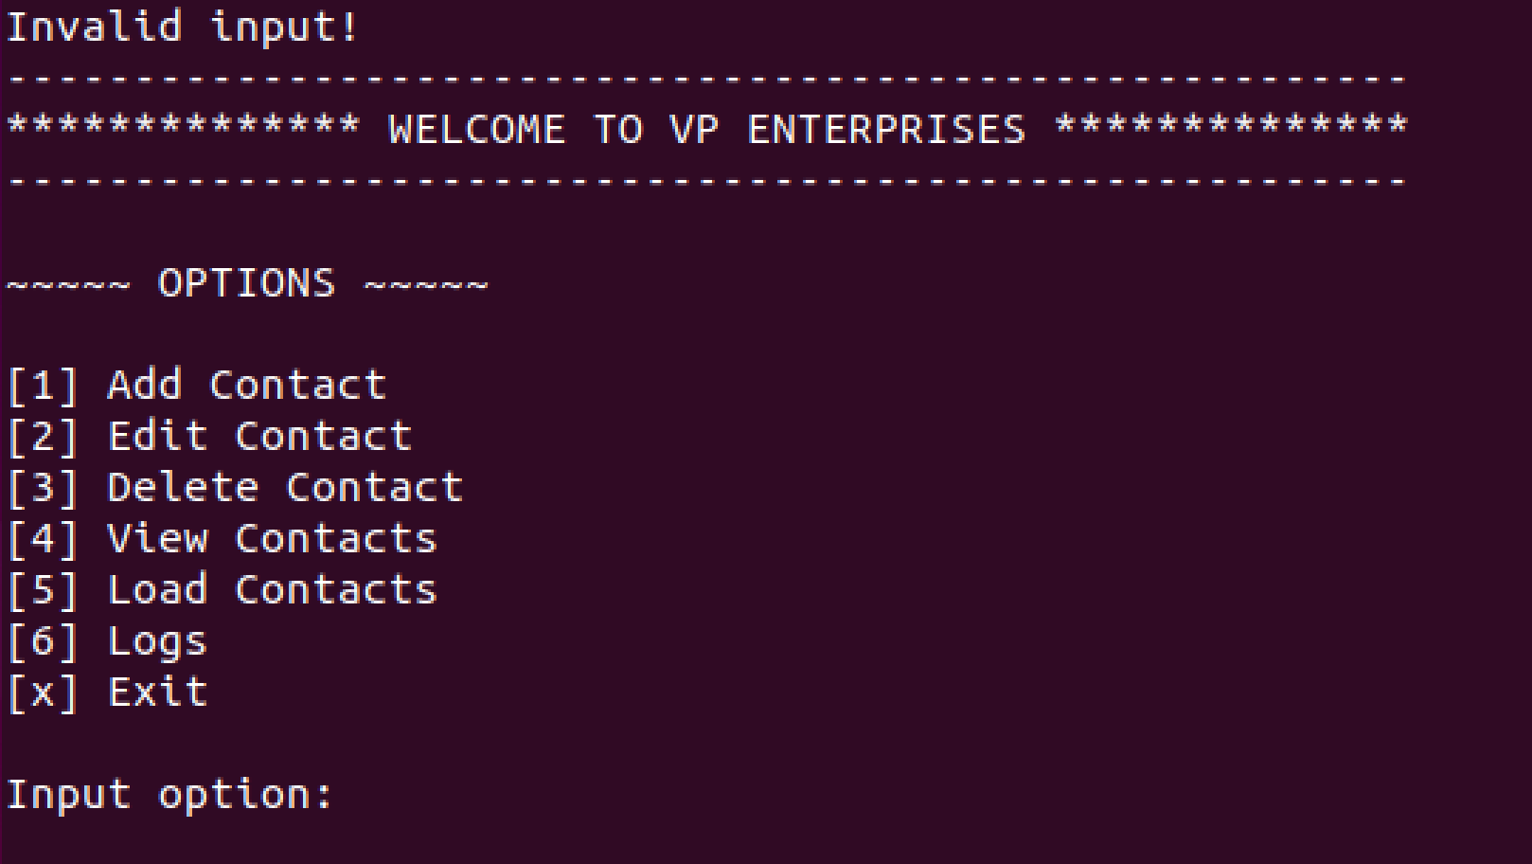

*Figure 3: Main menu page with invalid input*

1. If the user chooses the exit option, the program will terminate and displays a prompt.

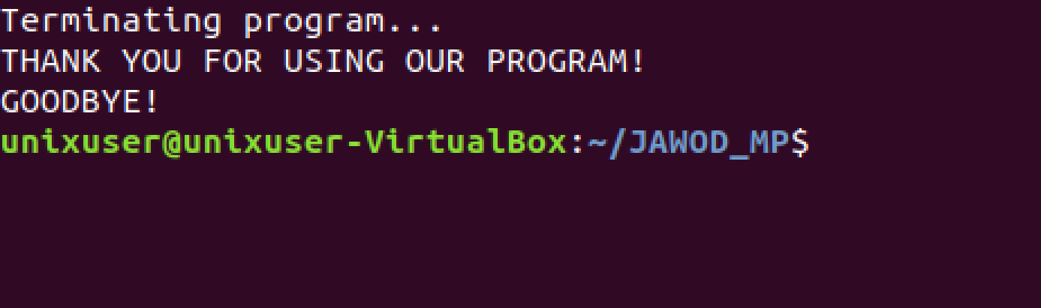

*Figure 4: Exit program display*

**Add Contact functionality**

Steps in using the Add Contact functionality:

1. If the user chooses the Add Contact functionality, the program will display the Add Contact functionality page. Once directed to the Add Contact page, it will prompt the user to input necessary information required such as First name, Middle name, Last name, Gender, Birth date, Mobile number, Nationality, Birth place, and Address.
2. An invalid input for each field will display an error prompt thus will ask the user to input the necessary information again.

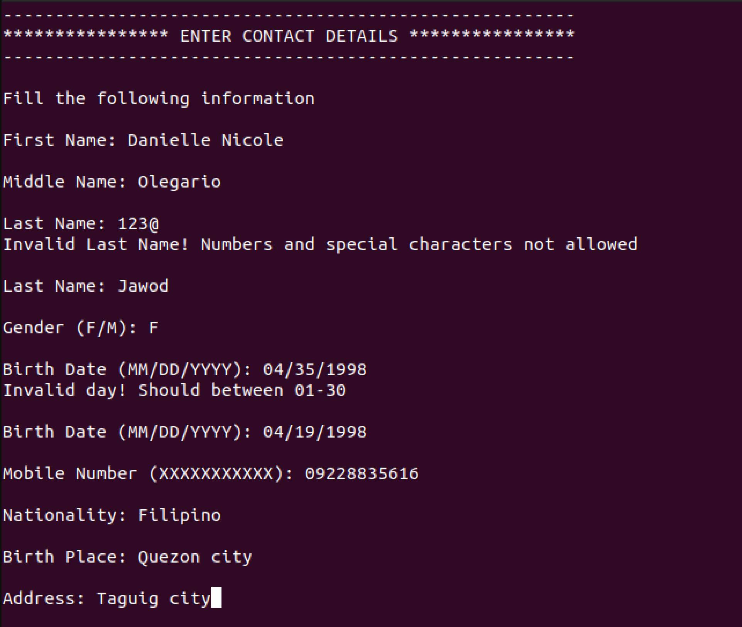

*Figure 5: Add Contact functionality*

1. Once all information is provided, the program will display a prompt whether the contact is successfully added to the address book or the contact is already existing thus not adding it to the address book. Once done, the program will ask if the user wants to add another contact thus enabling the user to execute the Add Contact functionality again. If not, the program will return to the menu page.

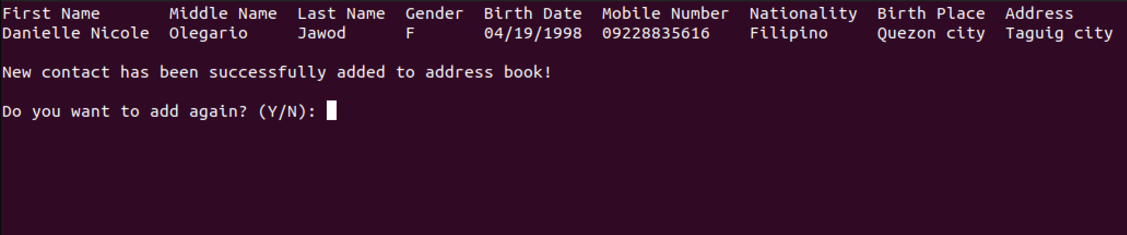*Figure 5: Add Contact functionality successful output*

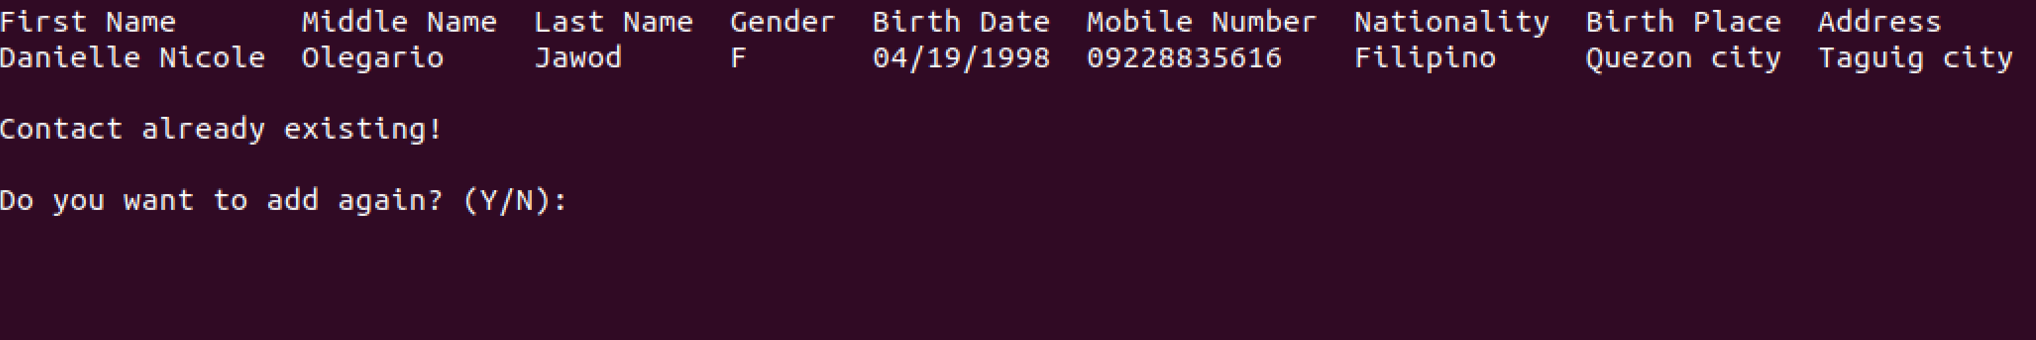

*Figure 6: Add Contact functionality existing contact*

**Edit Contact functionality**

Steps in using the Edit Contact functionality:

1. If the user chooses the Edit Contact functionality, the program will display the Edit Contact functionality page. Once directed to the Edit Contact page, it will prompt the user to input necessary information required such as First name, Middle name, and Last name of the desired contact to be edited.
2. An invalid input for each field will display an error prompt thus will ask the user to input the necessary information again.

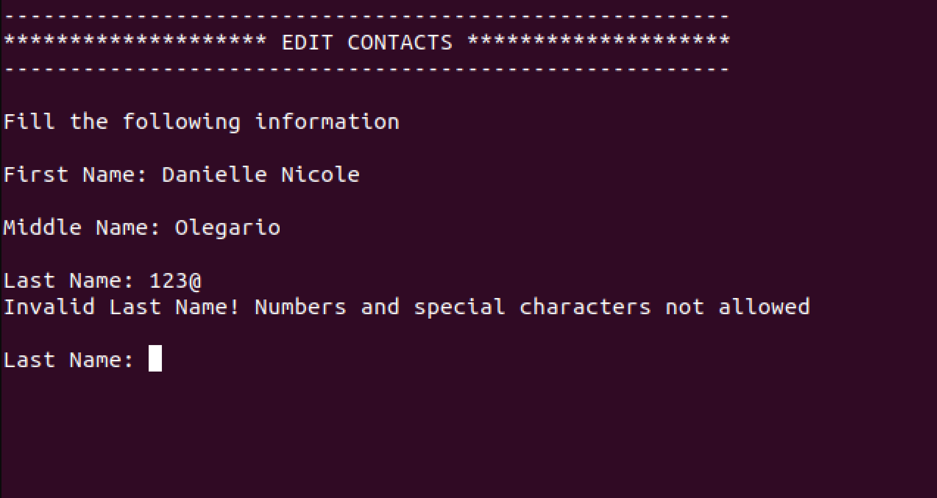

*Figure 7: Edit Contact functionality*

1. Once all information is provided, the program will display whether the desired contact with the information provided is existing from the address book. If not, the program will display an error prompt and will ask if the user wants to edit another contact. If existing, the program will display the information of the desired contact along with the available options on which field the user desires to edit. Once an option is provided, the user will be prompted to provide the corresponding information of the chosen field to be edited.

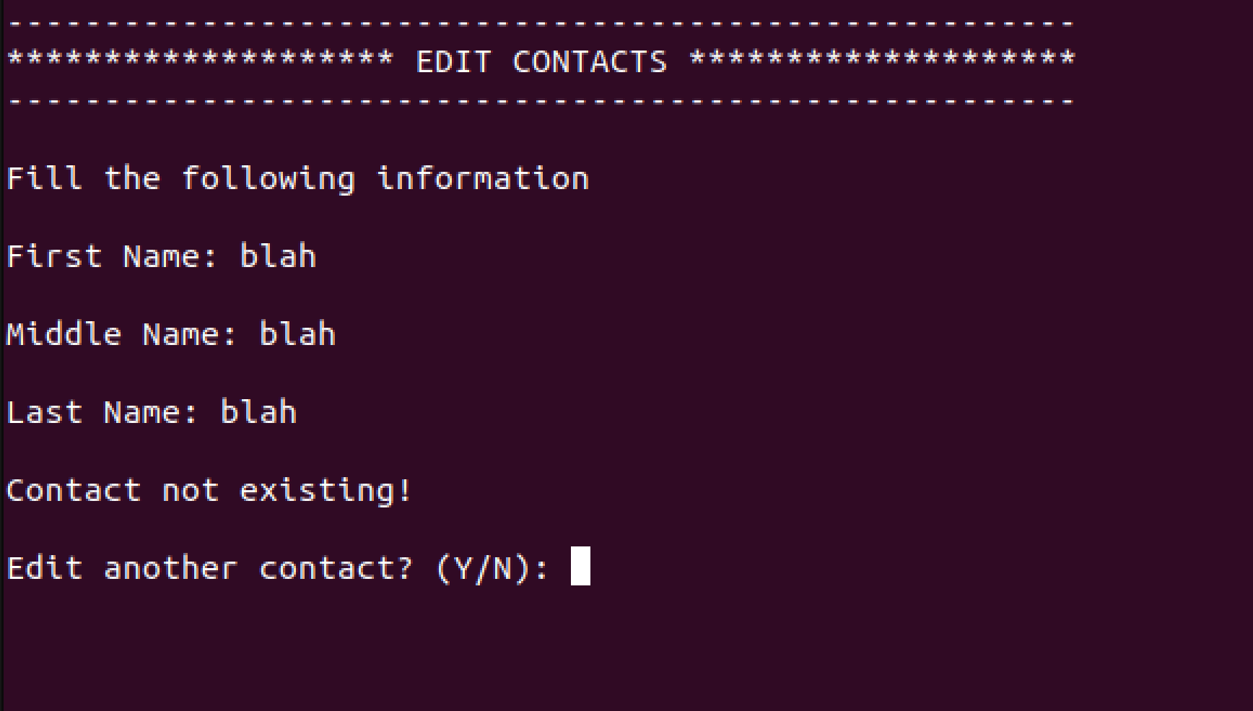

*Figure 8: Edit Contact functionality non existing contact*

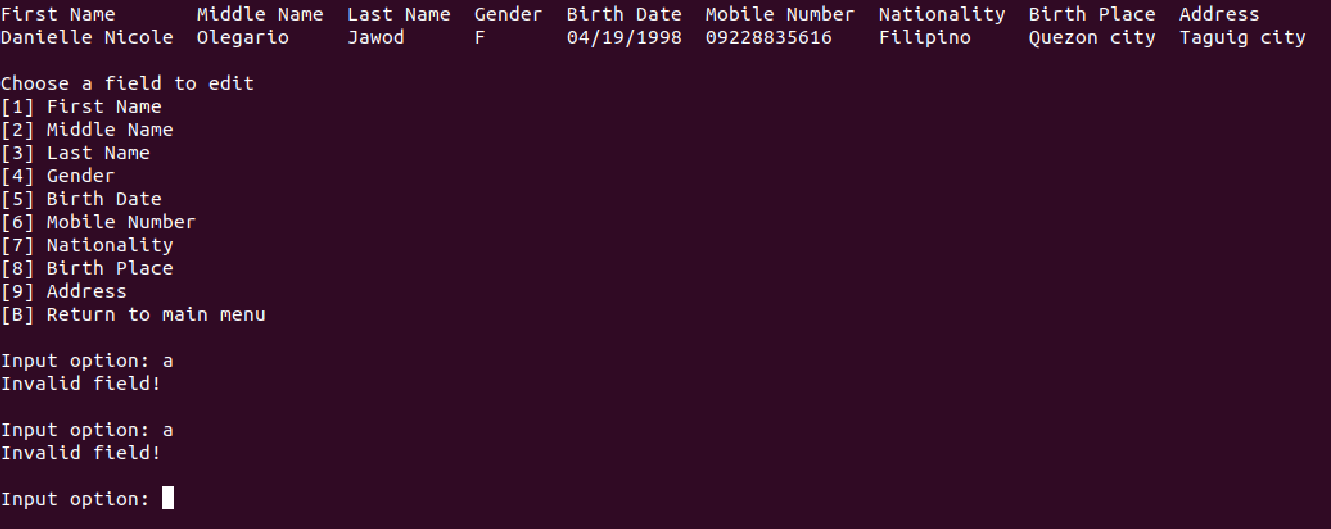

*Figure 9: Edit Contact functionality field selection*

1. An invalid input will display an error prompt thus will ask the user to input the necessary information again.

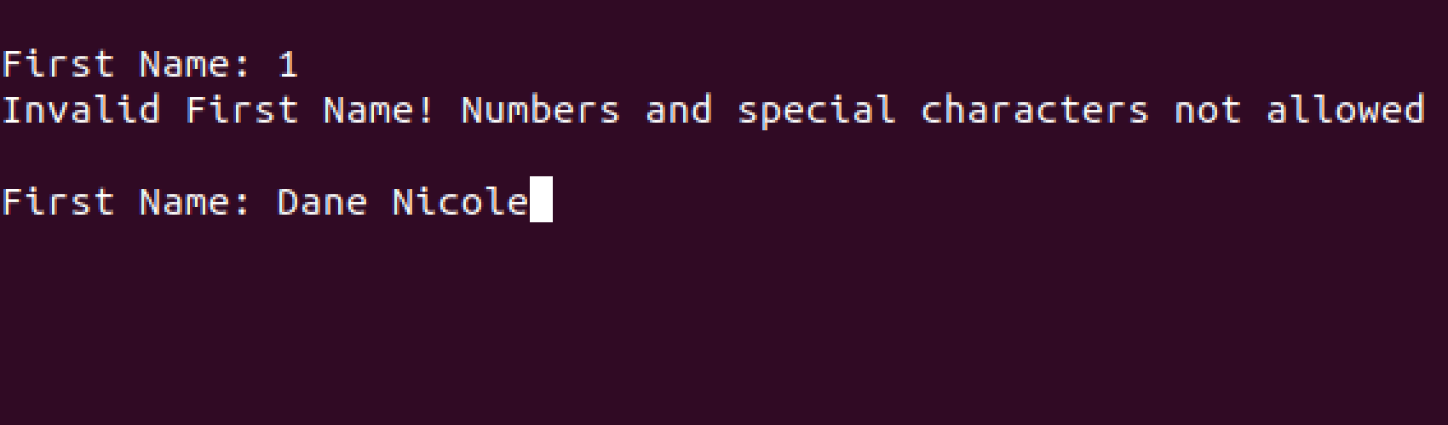

*Figure 10: Edit Contact functionality invalid field information*

1. Once the required information is provided, the program will display a prompt that the contact is successfully edited from the address book prompt and will ask if the user wants to edit another contact thus enabling the user to execute the Edit Contact functionality again. If not, the program will return to the menu page.

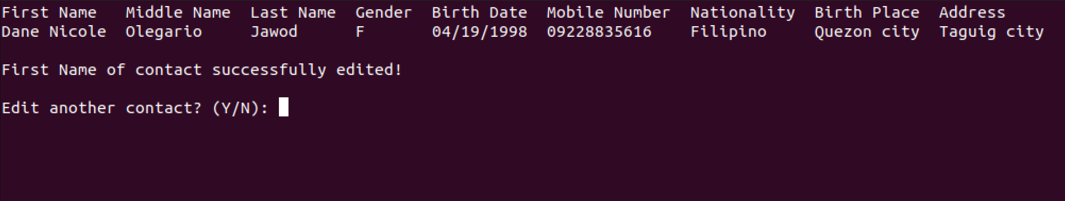

*Figure 11: Edit Contact functionality successful output*

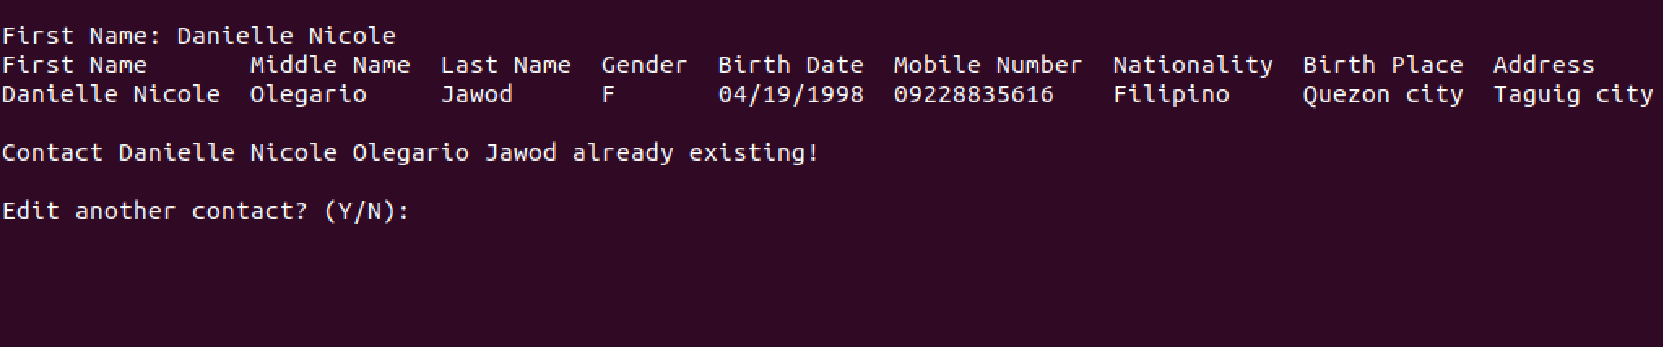

*Figure 12: Edit Contact functionality existing contact*

**Delete Contact functionality**

Steps in using the Delete Contact functionality:

1. If the user chooses the Delete Contacts functionality, the program will display the Delete Contacts functionality page. Once directed to the Delete Contacts page, it will prompt the user to choose an option from the Delete Contacts menu displayed namely Delete all contacts, Delete specific contact, and Return to main menu.

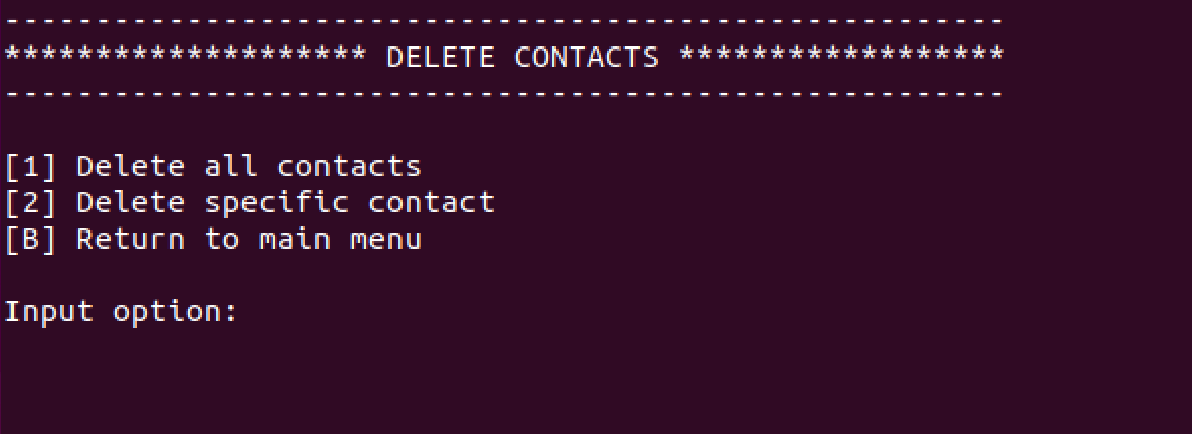

*Figure 13: Delete Contact functionality menu*

1. An invalid input will display an error prompt thus will ask the user to choose an option again. For a chosen option, the window display will be directed to the specified option page. If the user chooses the Return to main menu option, the program will return and displays the main menu again.

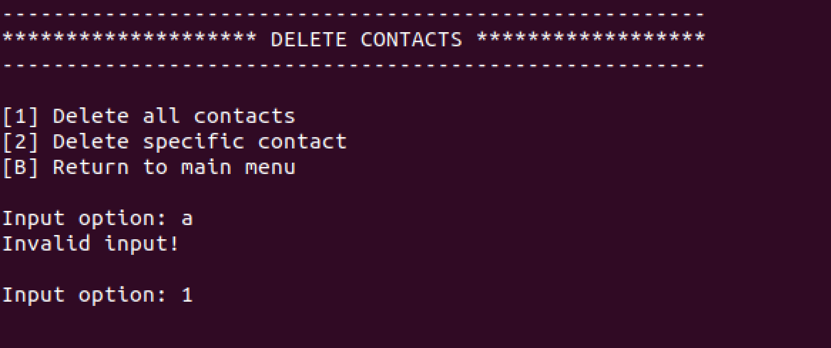

*Figure 14: Delete Contact functionality menu invalid input*

1. If the user chooses the Delete all contacts option, the program will ask if the user wants to deleted all contacts. If yes, all contacts will be deleted and will display a prompt that all contacts are successfully deleted from the address book. If no, the program will display a prompt that contacts are not deleted. Once done, the program will ask the user to go back to the Delete Contacts menu.

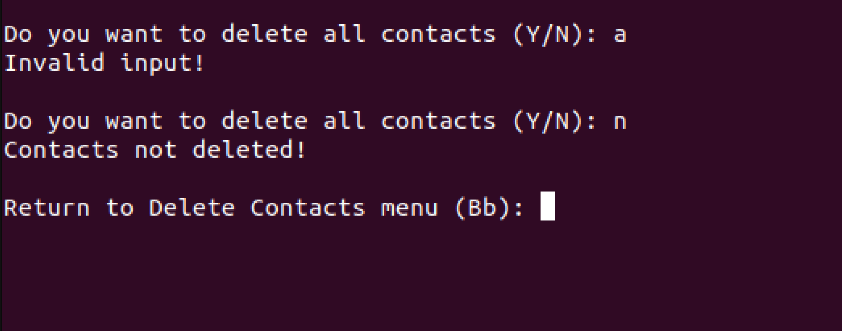

*Figure 15: Delete all contacts option*

1. If the user chooses the Delete specific contact option, the program will prompt the user to input necessary information required such as First name, Middle name, and Last name of the desired contact to be deleted.
2. An invalid input for each field will display an error prompt thus will ask the user to input the necessary information again.

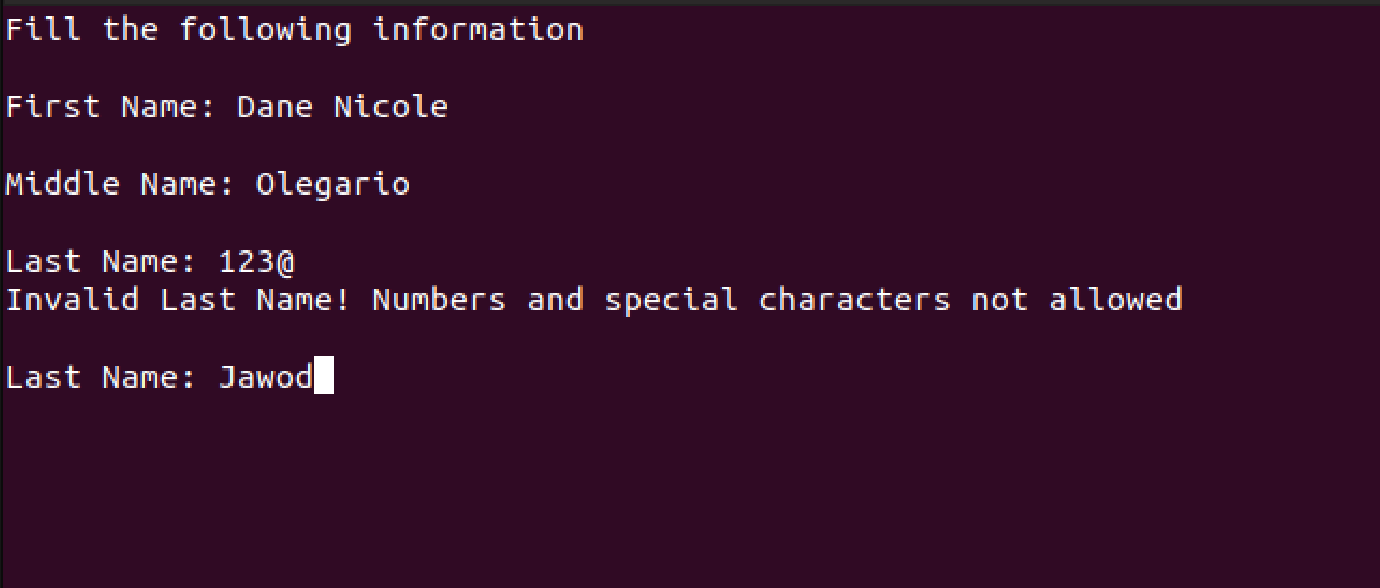

*Figure 16: Delete specific contact option*

1. Once all information is provided, the program will display whether the desired contact with the information provided is existing from the address book. If not, the program will display an error prompt and will ask whether the user wants to delete another contact again. If existing, the program will display the information of the desired contact to be deleted and will ask if the user wants to deleted the contact. If yes, the program display a prompt that the contact is successfully deleted from the address book. If no, the program will display a prompt that the contact is not deleted. Once done, the program will ask whether the user wants to delete another contact again. If yes will prompt the user to input necessary information required. If not, it will return to the Delete Contacts menu.

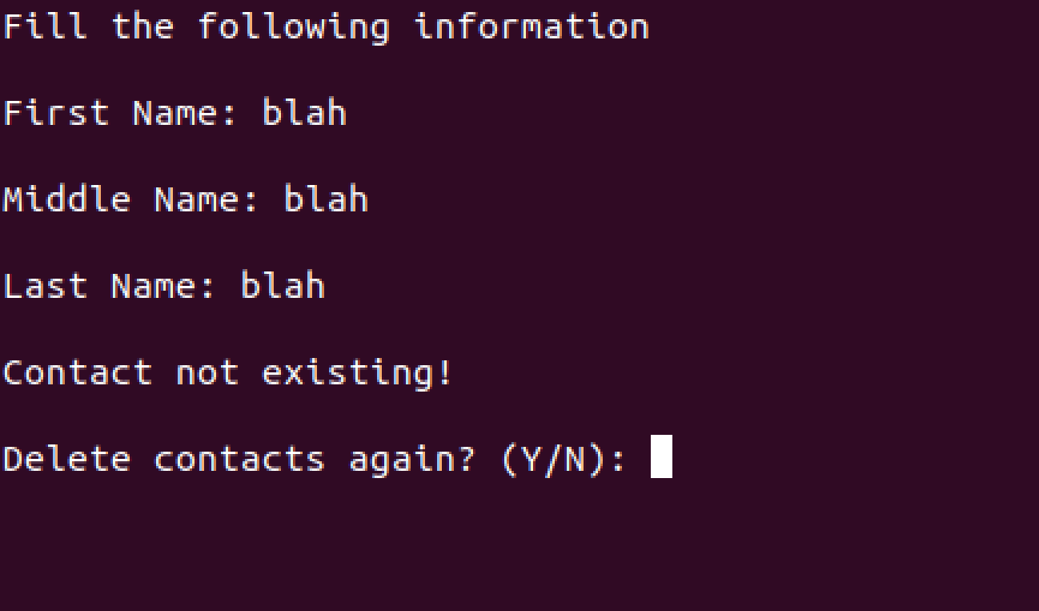

*Figure 17: Delete specific contact non existing contact*

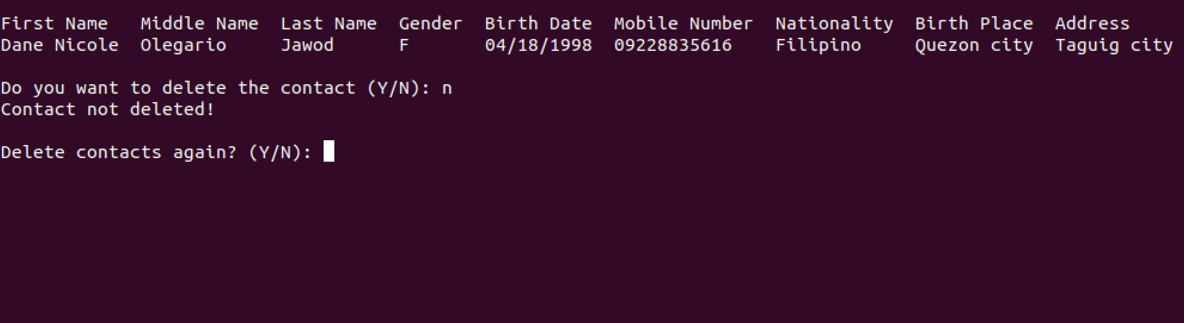

*Figure 18: Delete specific contact successful output*

**View Contact functionality**

Steps in using the View Contact functionality:

1. If the user chooses the View Contacts functionality, the program will display the View Contacts functionality page. Once directed to the View Contacts page, it will prompt the user to choose an option from the View Contacts menu displayed namely Sort contacts, Search contacts, and Return to main menu.

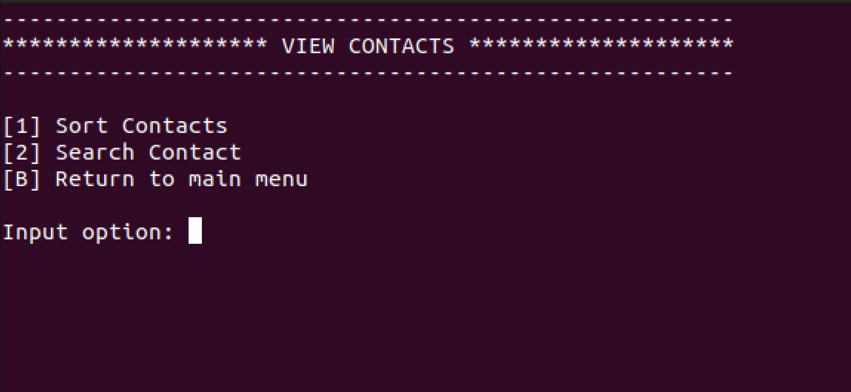

*Figure 19: View Contact functionality menu*

1. An invalid input will display an error prompt thus will ask the user to choose an option again. For a chosen option, the window display will be directed to the specified option page. If the user chooses the Return to main menu option, the program will return and displays the main menu again.

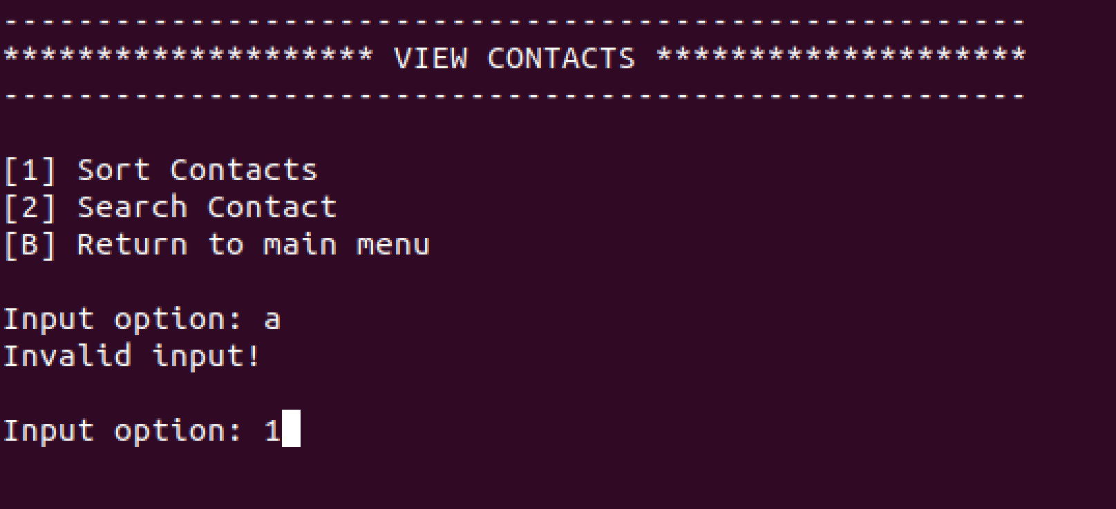

*Figure 20: View Contact functionality invalid input*

1. If the user chooses the Sort contacts option, the program will display the available options on which field the user desires to sort accordingly. Once an option is provided, the program will display the sorted contacts according to the chosen field. Once done, the program will display a prompt that the contacts are successfully sorted and will ask whether the user wants to sort again. If yes, it will return to the Sort contacts option. If not, it will return to the View Contacts menu.

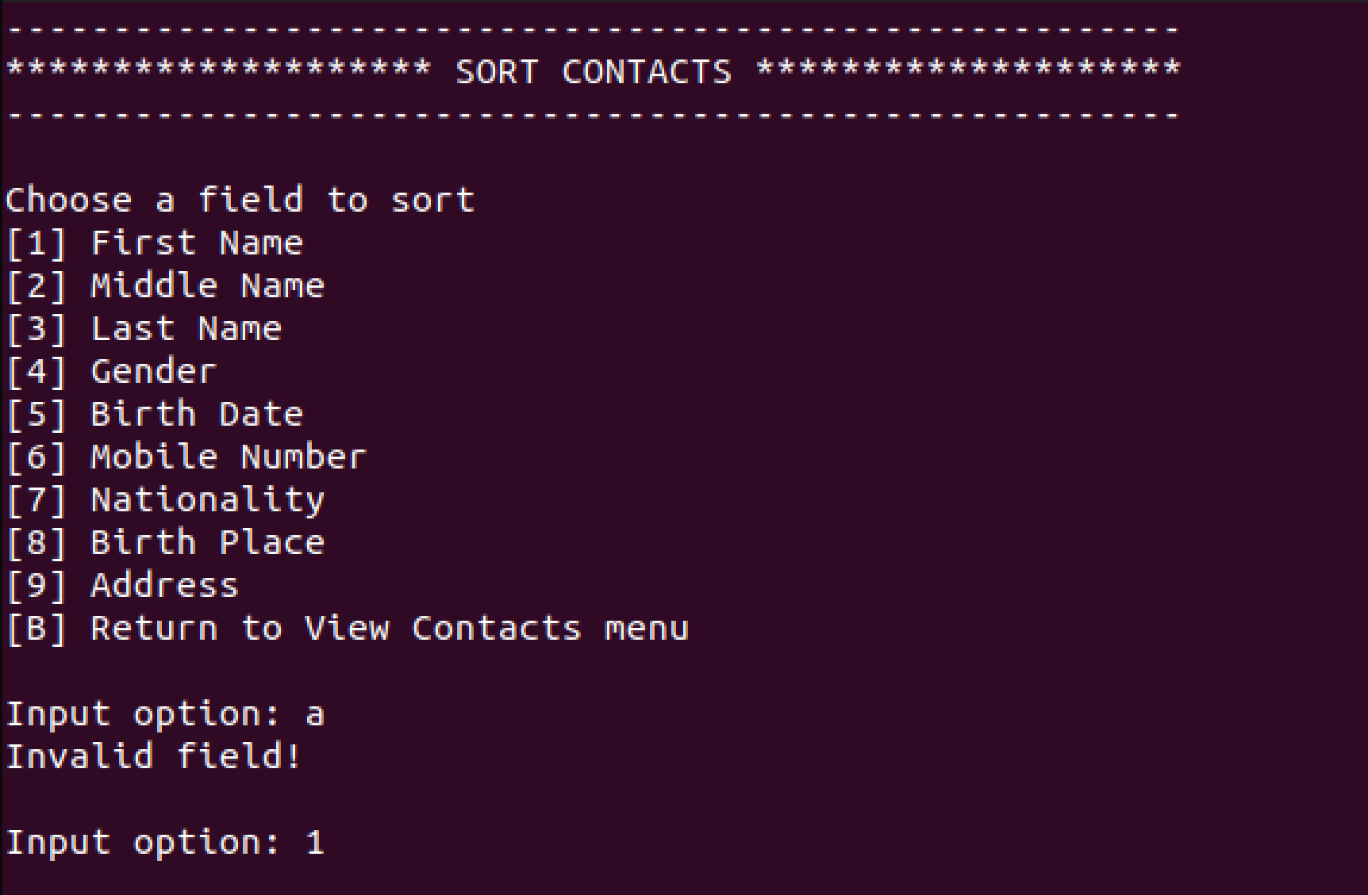

*Figure 21: Sort contacts option*

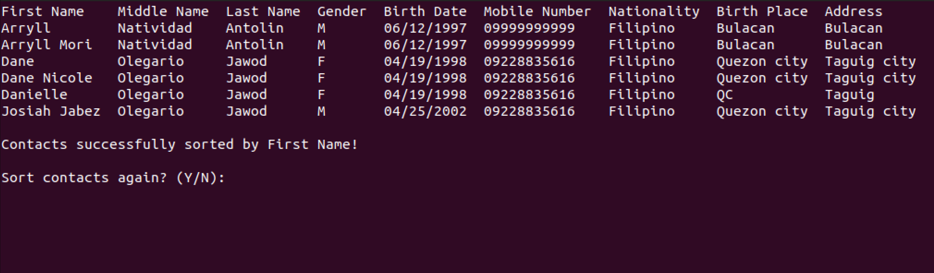

*Figure 22: Sort contacts output*

1. If the user chooses the Search contacts option, the program will display the available options on which field the user desires to search accordingly. Once an option is provided, the program will prompt the user to input the necessary information required corresponding to the chosen field of the desired contacts to be searched.

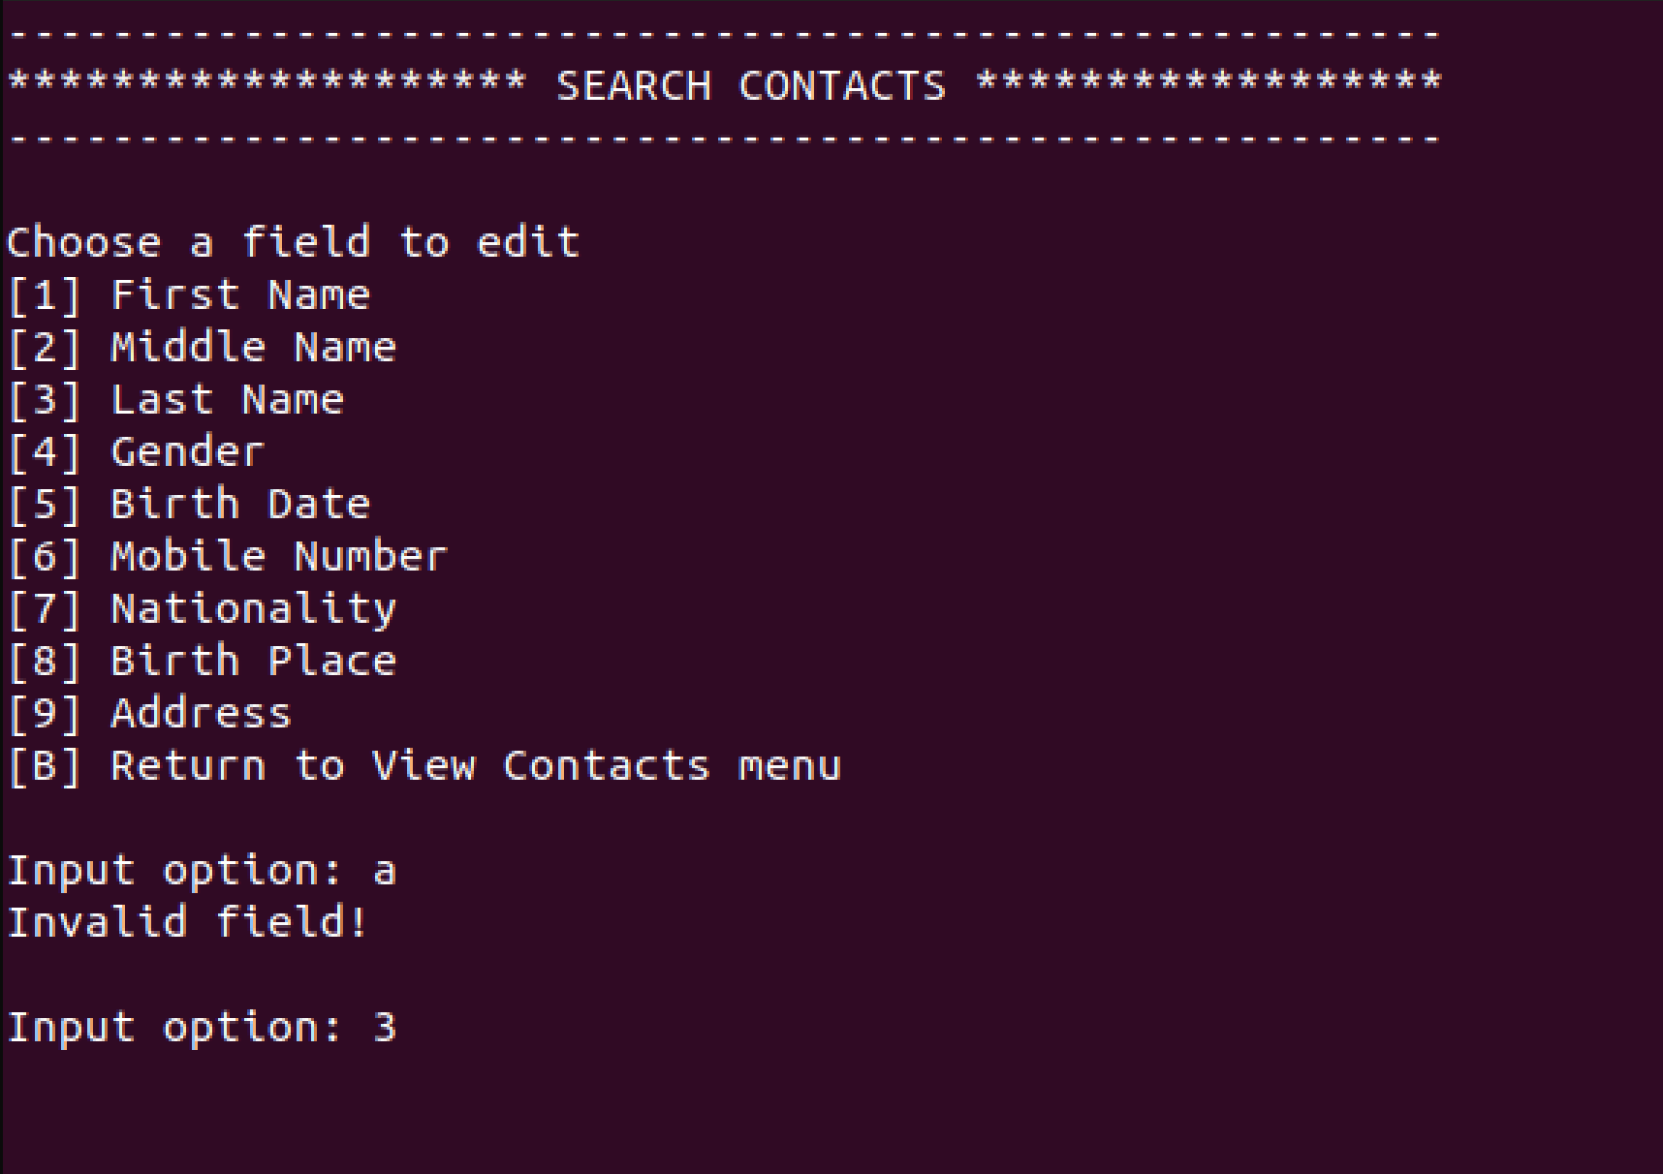

*Figure 23: Search contacts option*

1. An invalid input for the chosen field will display an error prompt thus will ask the user to input the necessary information again.

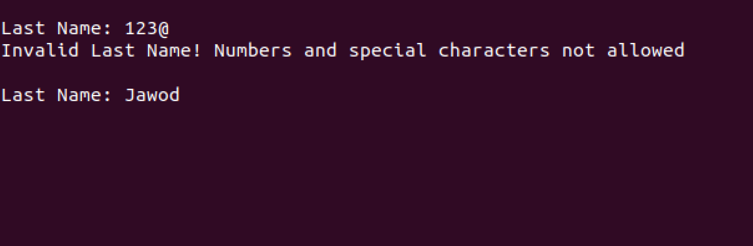

*Figure 24: Search contacts option*

1. Once information is provided, the program will display whether the desired contacts with the information provided is existing from the address book. If not existing, the program will display an error prompt and will ask whether the user wants to search again. If existing, the program will display the information of the desired contacts to be searched and will ask whether the user wants to search again. If yes, it will return to the Search contacts option. If not, it will return to the View Contacts menu.

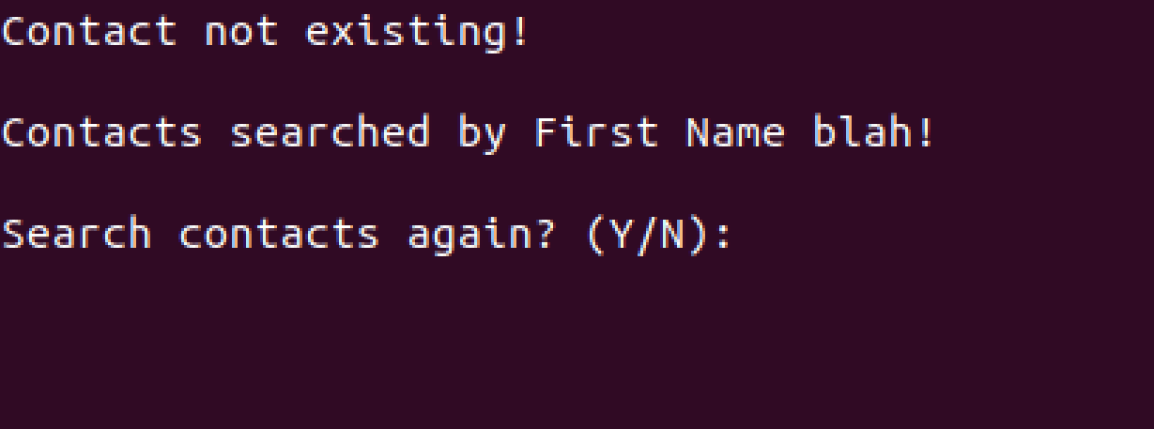

*Figure 25: Search contacts option non existing contact*

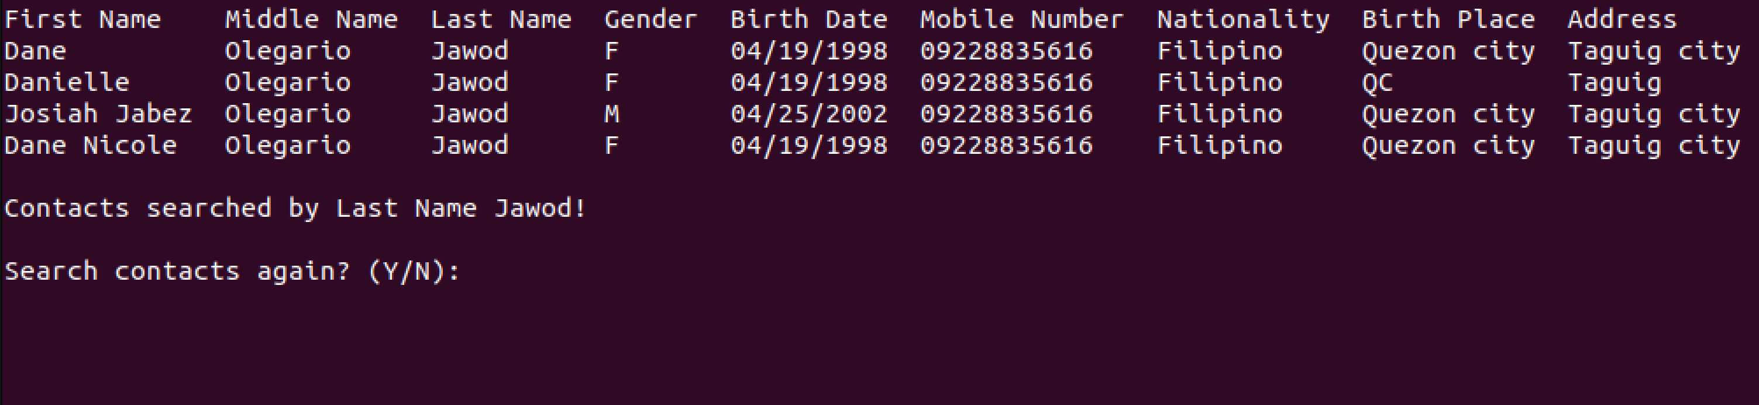

*Figure 26: Search contacts option successful output*

**Load Contact functionality**

Steps in using the Load Contact functionality:

1. If the user chooses the Load Contact functionality, the program will display the Load Contact functionality page. Once directed to the Load Contact page, it will prompt the user to provide the relative path location of batch file to be loaded to the address book.
2. Once the location of the batch file is provided, the program will display whether the desired location with the batch file provided is existing. If not existing, the program will display an error prompt and will ask whether the user wants to try again. If not, the program returns to the main menu.

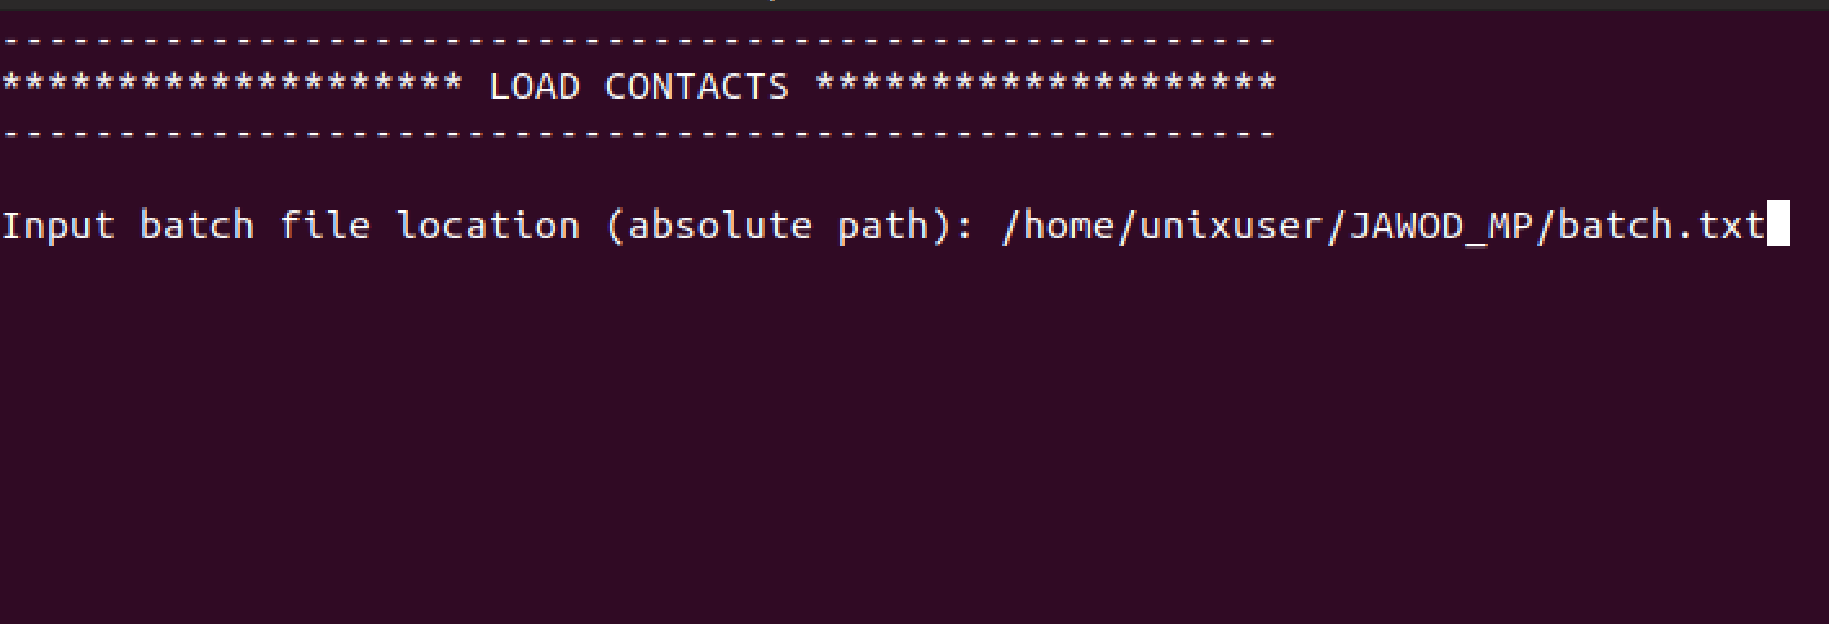

*Figure 27: Load contacts functionality*

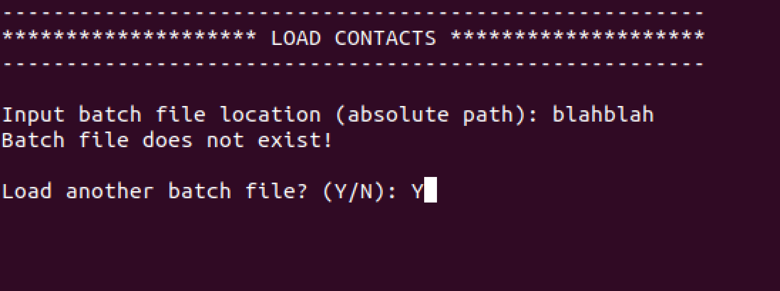

*Figure 28: Load contacts functionality non existing batch file*

1. If existing, the program will check whether the contacts stored in the batch file doesn’t meet the required fields, such information is invalid, or the particular owner of the contact is already existing in the address book. If so, the program will display a corresponding error prompt for each identified error from each contact in the batch file. If there are valid contacts from the batch file, the program will load the valid ones and display a prompt that the valid contacts are successfully loaded to the address book. If none, the program will display a prompt that there are no valid contatcs from the batch file loaded to the address book. Once done, the program will ask whether the user wants to try again. If not, the program returns to the main menu.

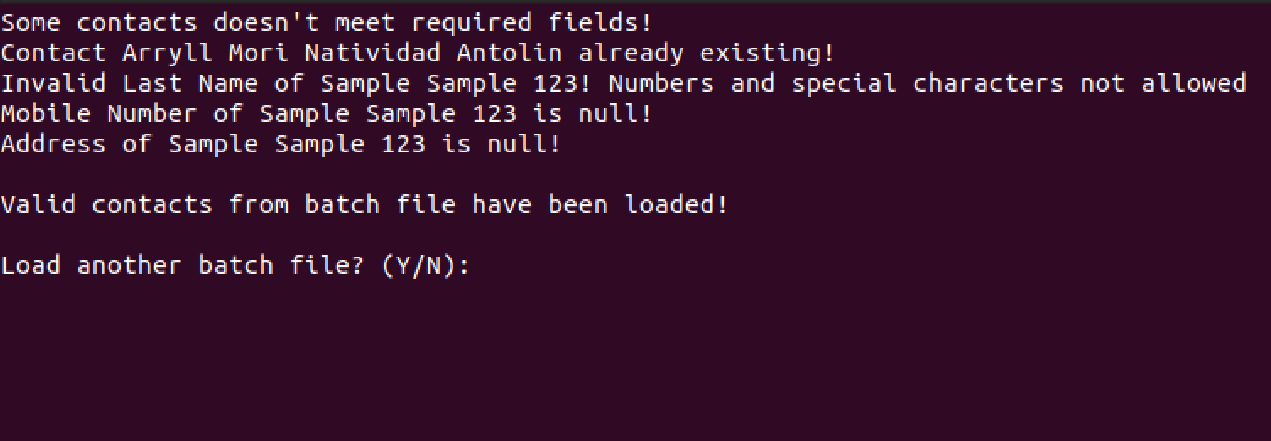

*Figure 29: Load contacts functionality output*

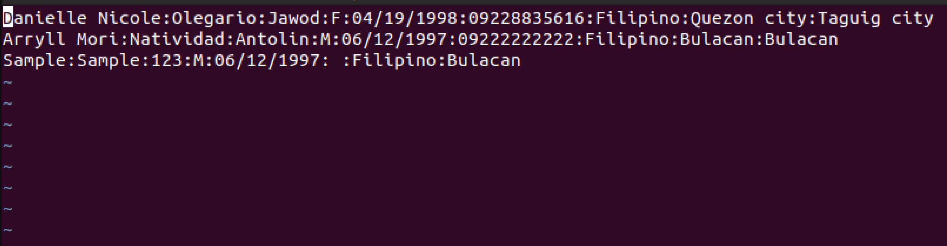

*Figure 30: Load contacts functionality batch file*

**Logs functionality**

Steps in using the Logs functionality:

1. If the user chooses the Logs functionality, the program will display the Logs functionality page. Once directed to the Logs page, the program will display the records of all results and errors for each functionality namely the Add Contact, Edit Contact, Delete Contact, View Contacts with sort and search functionality, and Load Contacts.
2. Once done, the program will ask the user to return to the main menu.

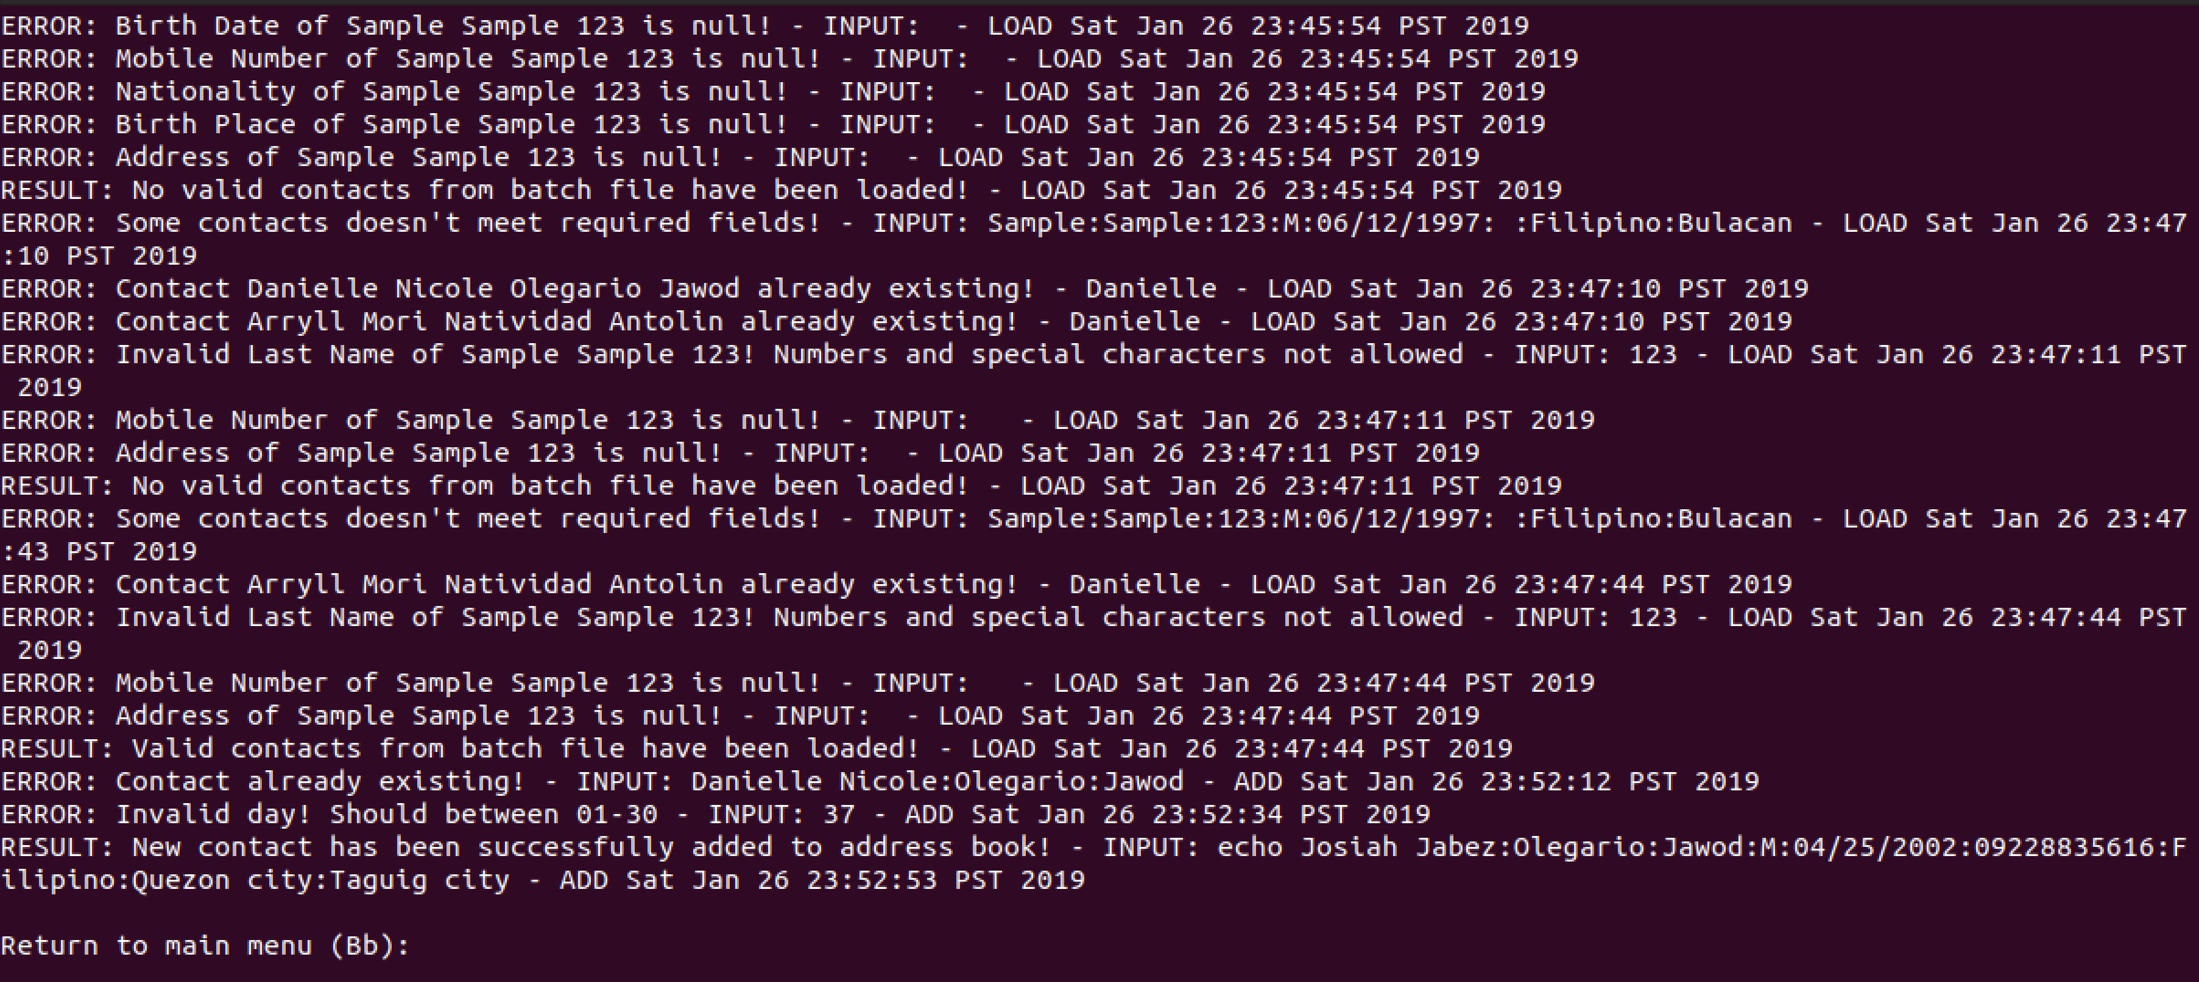

*Figure 31: Logs functionality*